Pypi Packages used for this assignments:

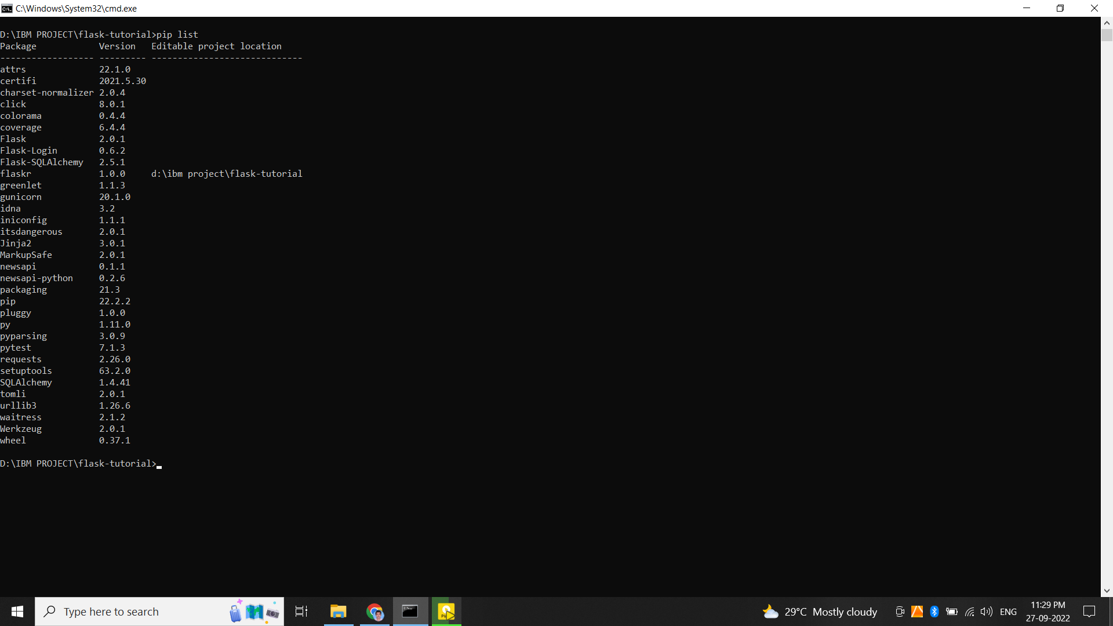

To run this project:

Create environmental variable file –venv

Cmd commands:

> set FLASK_APP=flaskr

> set FLASK_ENV=development

> flask run